***IBM Data Science Capstone Project***

**Recommender System for identification of Amenities in the vicinity of Hi-Tech City in Hyderabad using Four Square Application Programming Interface (API) Data**

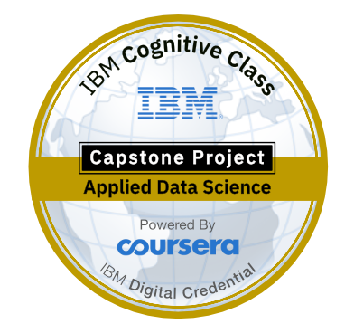

By

**Dr.V.Venkat Ramayya**

**Introduction:**

According to the Wikipedia, The Hyderabad Information Technology and Engineering Consultancy City, abbreviated as HITEC City, is an Indian [Information Technology](https://en.wikipedia.org/wiki/Information_Technology), [Engineering](https://en.wikipedia.org/wiki/Engineering), [Health informatics](https://en.wikipedia.org/wiki/Health_informatics), and [Bioinformatics](https://en.wikipedia.org/wiki/Bioinformatics); [business district](https://en.wikipedia.org/wiki/Business_district) located in [Hyderabad](https://en.wikipedia.org/wiki/Hyderabad), India. HITEC City is spread across 200 acres (81 ha) of land under suburbs of [Madhapur](https://en.wikipedia.org/wiki/Madhapur" \o "Madhapur), [Gachibowli](https://en.wikipedia.org/wiki/Gachibowli" \o "Gachibowli), [Kondapur](https://en.wikipedia.org/wiki/Kondapur,_Ranga_Reddy" \o "Kondapur, Ranga Reddy), [Manikonda](https://en.wikipedia.org/wiki/Manikonda" \o "Manikonda), and [Nanakramguda](https://en.wikipedia.org/wiki/Nanakramguda" \o "Nanakramguda), the technology township is also known as [Cyberabad](https://en.wikipedia.org/wiki/Cyberabad" \o "Cyberabad). HITEC City is within two kilometers of the residential and commercial suburb of [Jubilee Hills](https://en.wikipedia.org/wiki/Jubilee_Hills). The place is known for a number of software companies, restaurants, parks, places of cultural importance. Hyderabad Metro Rail (HMR), a prestigious Project of Govt. of Telangaa undertaken by L & T Ltd., is the most recent development and due to which a metro station was also set up in Hitech City catering to the needs of public transportation.

**Problem Definition & Objectives:**

In the Capstone Project of Coursera, it is proposed to develop a recommender system for HITEC City through identification of different types of amenities and categorise them. The objectives of the present study are listed below.

1. To collect required geospatial data to identify amenities in the vicinity of Shilparamam, HITEC city.
2. To collect geoJSON data for the chosen study area.
3. To collect Four square API data thorough general and premium calls to harness the information about the venues and their categories in the vicinity of HITEC City, Hyderabad.
4. To recommend venues to the users based on ratings and other statistics for a chosen venue category.

**Target Audience**

**The target audience who will be benefited by this project are:**

* People seeking different types of best amenities such as restaurants, coffee shops, furniture malls, textile shops etc in the vicinity of the study area.
* As the recommender system will aim to identify different types venues around a chosen neighbourhood, this data would be useful for business people who would like to set up their new shops to promote their business.